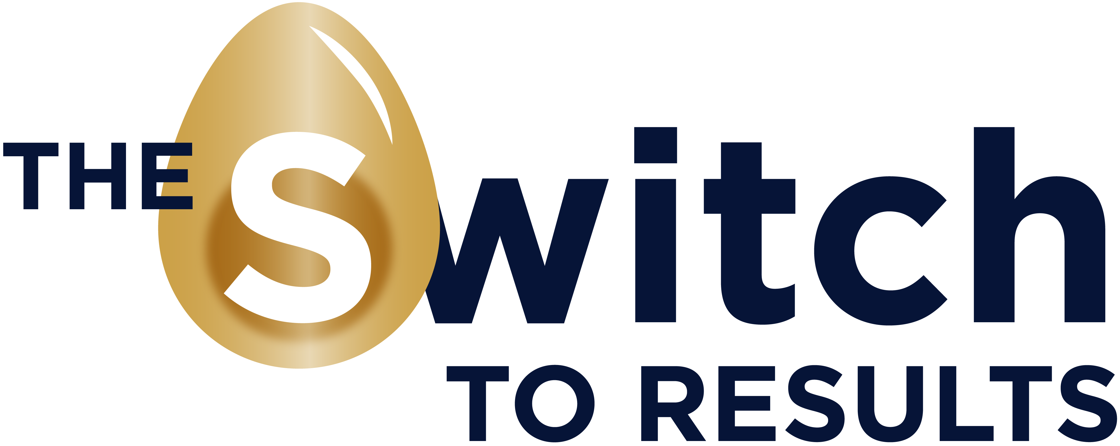

Do you like to work:

- MORE EFFECTIVELY,
- IN A GREAT ATMOSPHERE
- WITH HEALTHIER PEOPLE
- AND HAVE BETTER RESULTS?

Choose for a seminar in: Conscious Communication from the Switch to Results and support the ‘Widow and Orphan Care’ Foundation at the same time.

A lot of misunderstanding occurs when we don’t communicate clearly enough and we interpretate it wrongly.
Employees can get ill because of the feeling they didn’t felt seen or heard. That’s why it’s important to have in a good and conscious communication in your Company and listen well. Also our body language is a very important part of our communication, the most important part in our interhuman connection. From building a good sphere we create better results

It is important to learn the art of giving answers instead of reacting on the things we see, hear or notice.

Is your Company looking for a quality training focused on the goals above en would you like to support Widow’s and Orphan’s in developing countries?

Let us know and we will provide a 1 or 2 days workhsop in your Firm.
We will contribute 20 % of the fees to ‘The Widow and Orphan Care’ Foundation.

